**CONTENTS:**

1. **INTRODUCTION**
2. **ABSTRACT**
3. **METHODOLOGY**
4. **SOFTWARE REQUIRED**
5. **RESULTS AND DISCUSSION**
6. **CONCLUSION & FUTURE WORK**
7. **REFERENCES**

**INTRODUCTION**

* Facial emotion recognition is the process of detecting human emotions from facial expressions. The human brain recognizes emotions automatically, and software has now been developed that can recognize emotions as well. This technology is becoming more accurate all the time, and will eventually be able to read emotions as well as our brains do.
* AI can detect emotions by learning what each facial expression means and applying that knowledge to the new information presented to it. Emotional artificial intelligence, or emotion AI, is a technology that is capable of reading, imitating, interpreting, and responding to human facial expressions and emotions.
* 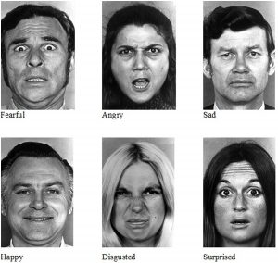

**ABSTRACT**

* Due to globalization and digital divide facial expression detection has received the primary attention in order to identify the criminals and breaches. Facial expressions are the changes occurring on the human face indicating a person's internal emotional states, intents or societal communications. Depending on the expressions on the face, human face is the most principal mode of conveying and deducing affective states of human ones. In real time, facial expression detection has become a prominent research area as it plays an important role in Human Computer Interaction. The applications of the facial expression detection are computer vision, biometric security, social interaction, emotional intelligence and social intelligence. This paper focuses a brief survey about various techniques used in facial expression detection and their respective pros and cons.​

**SOFTWARE REQUIRED:**

1. Python

2. Jupyter Notebook

**METHODOLOGY**

* Our goal is to design an application that will use a webcam(or an external camera) as an input device and it will then identify and classify the gesture into one of the categories that we are going to define.​
* In This Project We are Going To Use Real Time DataSet For Accuracy And Understanding

**Code**

from keras.preprocessing.image import img_to_array

from keras.models import load_model

import numpy as np

import imutils

import cv2

detection_model_path = 'haarcascade_files/haarcascade_frontalface_default.xml'

emotion_model_path = 'models/_mini_XCEPTION.102-0.66.hdf5'

face_detection = cv2.CascadeClassifier(detection_model_path)

emotion_classifier = load_model(emotion_model_path, compile=False)

EMOTIONS = ["angry" ,"disgust","scared", "happy", "sad", "surprised",

"neutral"]

cv2.namedWindow('your_face')

camera = cv2.VideoCapture(1)

while True:

frame = camera.read()[1]

frame = imutils.resize(frame,width=300)

cv2.imshow("Width=%dpx" % (width), frame)

gray = cv2.cvtColor(frame, cv2.COLOR_BGR2GRAY)

faces = face_detection.detectMultiScale(gray,scaleFactor=1.1,minNeighbors=5,minSize=(30,30),flags=cv2.CASCADE_SCALE_IMAGE)

canvas = np.zeros((250, 300, 3), dtype="uint8")

frameClone = frame.copy()

if len(faces) > 0:

faces = sorted(faces, reverse=True,

key=lambda x: (x[2] - x[0]) * (x[3] - x[1]))[0]

(fX, fY, fW, fH) = faces

roi = gray[fY:fY + fH, fX:fX + fW]

roi = cv2.resize(roi, (64, 64))

roi = roi.astype("float") / 255.0

roi = img_to_array(roi)

roi = np.expand_dims(roi, axis=0)

preds = emotion_classifier.predict(roi)[0]

emotion_probability = np.max(preds)

label = EMOTIONS[preds.argmax()]

else: continue

for (i, (emotion, prob)) in enumerate(zip(EMOTIONS, preds)):

text = "{}: {:.2f}%".format(emotion, prob * 100)

w = int(prob * 300)

cv2.rectangle(canvas, (7, (i * 35) + 5),

(w, (i * 35) + 35), (0, 0, 255), -1)

cv2.putText(canvas, text, (10, (i * 35) + 23),

cv2.FONT_HERSHEY_SIMPLEX, 0.45,

(255, 255, 255), 2)

cv2.putText(frameClone, label, (fX, fY - 10),

cv2.FONT_HERSHEY_SIMPLEX, 0.45, (0, 0, 255), 2)

cv2.rectangle(frameClone, (fX, fY), (fX + fW, fY + fH),

(0, 0, 255), 2)

cv2.imshow('your_face', frameClone)

cv2.imshow("Probabilities", canvas)

if cv2.waitKey(1) & 0xFF == ord('q'):

break

camera.release()

cv2.destroyAllWindows()

**Output**

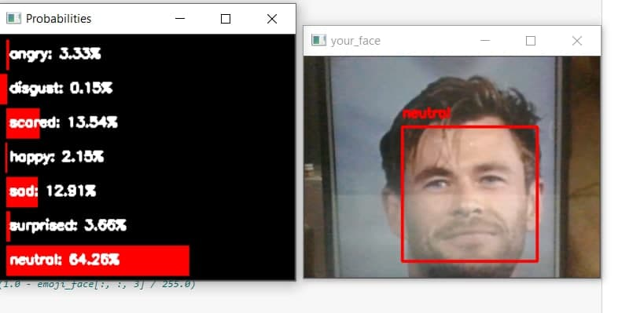

**CONCLUSION & FUTURE WORK**

An algorithm for real-time emotion recognition using virtual markers through an optical flow algorithm has been developed to create a real-time emotion recognition system with less computational complexity (execution time, memory) using facial expressions and EEG signals. This algorithm works effectively in uneven lightning and subject head rotation (up to 25°), different backgrounds, and various skin tones. The system aims to help physically disabled people (deaf, dumb, and bedridden), in addition to its benefit for Autism children to recognize the feelings of others. Moreover, it can drive business outcomes and judge the emotional responses of the audience. Rather than helping to maximize learning, it has a good benefit in personalized e-learning.

**REFERENCES:**

* <https://www.researchgate.net/publication/284626785_Hand_Gesture_Recognition_A_Literature_Review#:~:text=Hand%20gesture%20recognition%20system%20received,gesture%20recognition%20systems%20is%20presented>.​
* <https://www.ijtrs.com/uploaded_paper/Literature%20Survey%20on%20Hand%20Gesture%201.pdf>​
* <https://www.mdpi.com/1424-8220/20/9/2467>​
* <https://link.springer.com/article/10.1007/s11042-018-5971-z>​
* <https://openaccess.thecvf.com/content_cvpr_2018/papers/Yang_Facial_Expression_Recognition_CVPR_2018_paper.pdf>​
* <https://ieeexplore.ieee.org/document/8634348>
* A. D. Bagdanov, A. Del Bimbo, L. Seidenari, and L. Usai, “Real-time hand status recognition from RGB-D imagery,” in *Proceedings of the 21st International Conference on Pattern Recognition (ICPR '12)*, pp. 2456–2459, November 2012.View at: [Google Scholar](https://scholar.google.com/scholar_lookup?title=Real-time%20hand%20status%20recognition%20from%20RGB-D%20imagery&author=A.%20D.%20Bagdanov&author=A.%20Del%20Bimbo&author=L.%20Seidenari&author=&author=L.%20Usai)
* M. Elmezain, A. Al-Hamadi, and B. Michaelis, “A robust method for hand gesture segmentation and recognition using forward spotting scheme in conditional random fields,” in *Proceedings of the 20th International Conference on Pattern Recognition (ICPR '10)*, pp. 3850–3853, August 2010.View at: [Publisher Site](https://doi.org/10.1109/ICPR.2010.938) | [Google Scholar](https://scholar.google.com/scholar_lookup?title=A%20robust%20method%20for%20hand%20gesture%20segmentation%20and%20recognition%20using%20forward%20spotting%20scheme%20in%20conditional%20random%20fields&author=M.%20Elmezain&author=A.%20Al-Hamadi&author=&author=B.%20Michaelis)